Facilitators of The Parent Project® - Changing Destructive Adolescent Behavior will be eligible to train the Parent Project, Sr. and Jr. curriculum Facilitators training on behalf of Partners For Peace will receive a $550 Facilitators stipend. Click on The Parent Project graphic for more information on The Parent Project curriculum or go to www.parentproject.com
The Parent Project® Application Form

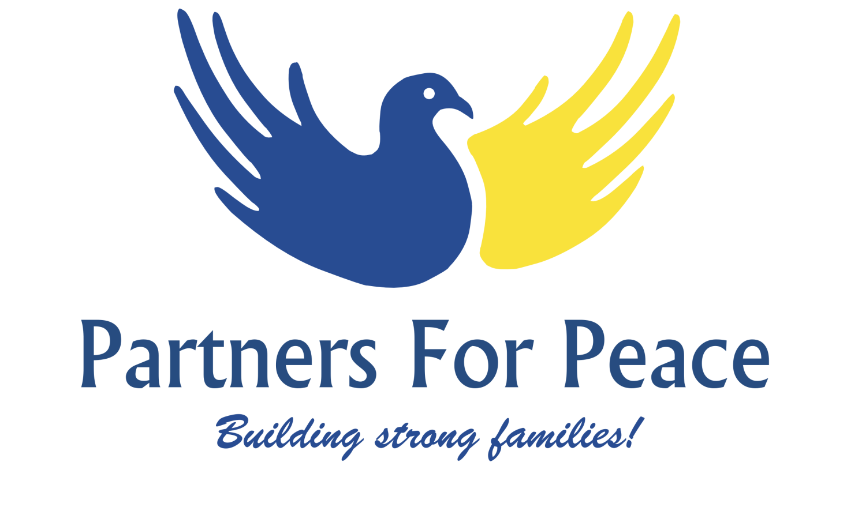

Yes, I would like to be part of Partners For Peace (P4P), The Parent Project,® Facilitators Team!
☐
Name | Click here to enter text.
Employer | Click here to enter text.
Address | Click here to enter text.
Phone | Click here to enter text.
Email | Click here to enter text.
☐ Yes, I can train in Spanish
Briefly describe your experience facilitating groups of adults:
Click here to enter text.
List three key strengths you bring to the table as a P4P Facilitator:
Click here to enter text.
What do you like the most about facilitating?
Click here to enter text.
What is the most challenging facilitation experience you have had, and what did you learn from that experience?
Click here to enter text.
You do not have to be an expert on the following topics to be a great Facilitator; however we would like to know your comfort level on the following topics:
Leadership – Recruiting, Mentoring, Class Follow-Up:

Marketing – Advertising classes, Networking, Outreach Events

Organization Skills – Class prep, following-up with absent participants

Availability:
I am available:
Mondays ☐ Tuesdays ☐ Wednesdays☐ Thursdays☐ Fridays☐
Daytime Only ☐ Evenings Only ☐ Flexible Schedule☐
I can attend the Facilitators Training on February 25, 26, 27, 28 and March 1, from 8:00 AM – 5:00 PM in Salinas. ☐Yes
The $895 Facilitator cost is covered by a generous grants through CalVIP-Salinas, CalVIP – Seaside, CDGG – City of Salinas and Community Foundation for Monterey County. The class has a $250 registration fee per person to cover costs not covered by the grant (contact us if you need a full or partial scholarship). Payment Method:
(Mail checks payable to: Partners For Peace, to PO Box 2473, Salinas, CA 93902 or pay through our Paypal account on the home page of our web site. Purchase orders are also accepted.)
☐My Agency is sponsoring me
☐I am paying the $250 Course Registration in full
☐I need Financial Assistance. I can afford to pay: Click here to enter text.
Other Questions or Comments related to your interest in joining our Facilitators Team?
Click here to enter text.

Please save and send to: amdrigal@p4pmc.org
Questions: Vicki Law – 831-726-6459 (cell) (831) 754-3888 (office)

